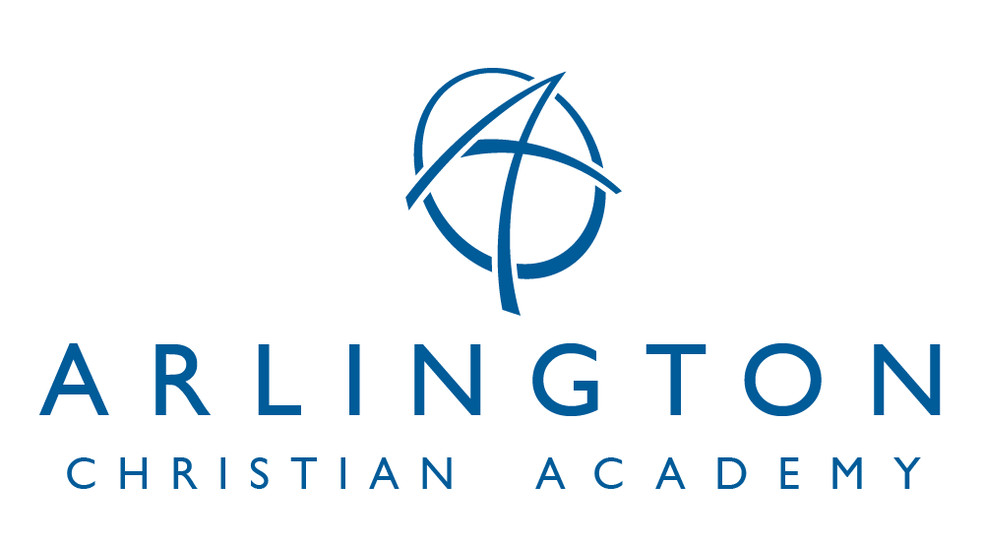
9801 Arlington Church Road * Mint Hill, NC 28227 * (704) 545-4589 * www.arlingtonacademy.org
FINANCIAL INFORMATION
2024-2025 SCHOOL YEAR
APPLICATION PROCESSING FEE: $250.00 per student for new students (non-refundable). This Application Processing Fee is required at the time of application to ACA. This fee covers the costs of processing the application and any testing that is required.
CAPITAL IMPROVEMENT FEE: $100.00 per student (non-refundable). The Capital Improvement Fee covers the acquisition, upgrades, improvement and building program of our facilities. This fee helps cover expenses like classroom maintenance and repairs, restroom construction and maintenance, playground maintenance, parking lot construction, etc.
TUITION: $7,000.00 annually. This can be paid in any of the following methods:
- Paid in full by September 30, 2024.
- Paid in monthly installments of $700.00.
- Paid quarterly by October 25, 2024, December 20, 2024, February 20, 2025, and May 20, 2025.
ADVANTAGE: If full payment is made by September 30, 2024, a 2% discount will be applied to tuition.
DISCOUNTS: Please contact Arlington Christian Academy Administration at csustar@arlingtonacademy.org to determine what additional discounts your student is qualified to receive.
OPPORTUNITY SCHOLARSHIP is the Noth Carolina State Education Assistance Authority. For the 2024-2025 school year the income cap for families to receive the scholarship has been increased. A student’s scholarship amount will be based on household income. Scholarship amounts will range from approximately $3,000 to approximately $7,000.
The Opportunity Scholarship application for the 2024-2025 school year will open on February 1, 2024. Families must apply by February 29, 2024 to receive priority consideration. More information about the application process will be available on the program website at www.ncseaa.edu.
LATE FEES: There will be a $30.00 late fee accessed to all accounts that are 15 days delinquent. There will be a $30.00 fee accessed to all returned checks.
Revised 1/11/2024 CS

