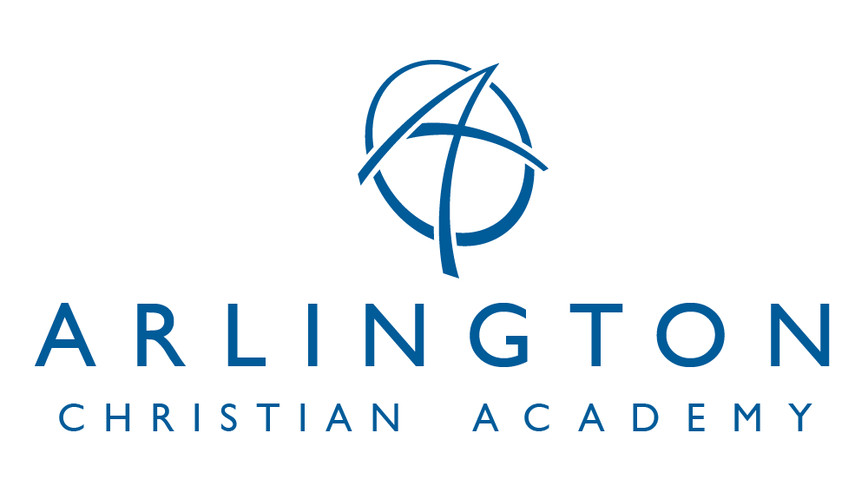
STATEMENT OF COOPERATION
Finances: We understand it is necessary that parents pay tuition for the amount stated on the Tuition and Financial information statement.
If tuition payments and fees are not received by 15th of each month, a $10.00 late charge will be added each month to the account. Tuition that becomes 30 days past due will result in the student being withheld from attending school until such amounts due to ACA are made current.
A fee of $30.00 will be charged for each returned check.
Volunteers: In order to help ensure the safety of our students, Arlington Christian Academy has an established volunteer policy that is outlined in the Student Handbook. We understand that in order to participate as a volunteer we will abide by the guidelines set forth in the volunteer policy and complete any necessary forms.
Personal Information: Arlington Christian Academy is committed to ensuring that your privacy is protected. ACA will use personal information, such as an e-mail address and phone numbers, for school-related communication exclusive of third-party services. Personal information will not be shared, sold, or distributed outside of this ministry. We likewise, authorize ACA, or anyone authorized by ACA, to use and reproduce all audio and video tapes and photographs which ACA takes of our child(ren) or any family member produced for school literature, advertisements, and promotional purposes without further compensation. All copies, masters, negatives, pictures and proofs shall constitute ACA properly, solely and completely.
Discipline: We believe discipline is a necessary aspect of our child(ren)’s education. We give permission for our child(ren)’s teacher and/or administration to make and enforce classroom regulations in a manner consistent with Christian principles and discipline as set forth in Scriptures. Detention may be assigned, and transportation will be the responsibility of the parents. Parents will be sent written notice of such assignments. We understand that we have the responsibility to actively support the authority, philosophy, objectives, policies, procedures, and discipline of the school as established by the Board of Governors.
School Activities: We, the parents, give permission for our child(ren) to take part in any and all school activities, class field trips, including sports and school-sponsored trips away from the school premises, and absolve the school from liability to us or our child because of any injury to us or our child at school or during any school activity.
In case of emergency or serious illness, we request the school contact us first. If we are not available, please contact the designated emergency contact. If the emergency contact cannot be reached, the school has our permission to make whatever arrangements deemed necessary for our child(ren)’s treatment. If the emergency is life threatening and we cannot be reached, the physician has permission to act accordingly absolving the school of any liability. This statement of cooperation will serve as a blanket permission skip from August 1, 2023 to July 30, 2024.
Parental Commitment: We agree that as parents of children who attend Arlington Christian Academy, if we have a complaint, we will in no case complain to other parents, but will register only necessary complaints with the teacher or administration following the Matthew 18 principle. In addition, we also agree not to post negative or derogatory statements about Arlington Christian Academy, it’s staff or student body on any form of social media. We pledge our full cooperation to keep doctrinal controversy out of the school. We agree to support the school with our prayers and positive attitude. We understand that if at any time the school determines, in its sole discretion, that our actions do not support the ministry, or reflect a lack of cooperation and commitment to the home and school working together, the school has the right to request the withdrawal of our child(ren). We understand that the school reserves the right to dismiss our student(s) for lack of cooperation in the part of the student, parent and/or guardian. Admission to Arlington Christian Academy is a privilege and not a right. It is a privilege granted with the understanding that students will desire to live a Bible-believing, consecrated Christians. Conduct exemplary of developing young Christians is expected. Drinking alcoholic beverages, using marijuana or other illegal drugs, smoking, profanity disrespect for authority or property, improper sexual behavior and abuse of others are prohibited. This applies to school and non-school related social activities where unacceptable behavior would have an adverse effect on the testimony of the school. We are aware of the “No Bullying Policy” in the Parent/Student Handbook and agree to sign the school’s “No Bullying Pledge.” We understand, agree with and will support the school’s Computer Acceptable Use Policy. As an ACA family, we will commit to the principle of the sanctity of marriage between a man and a woman.
Faith Statement: The general nature and object of Arlington Christian Academy shall be to conduct an institution or institutions of learning for the general education of youth in the essentials of culture and its arts and sciences, giving special emphasis to the Christian faith and the ethics revealed in the Holy Scriptures; prepare young people academically and spiritually to impact society; unqualifiedly affirming and teaching the divine inspiration of the entire Bible the creation of man by the direct act of God; the incarnation and virgin birth of our Lord and Savior Jesus Christ; His identification as the Son of God; His vicarious atonement for the sins of all people by the shedding of His blood on the cross; the resurrection of His body from the tomb; His power to save mankind from sin; the new birth through the regeneration by the Holy Spirit; and the gift of eternal life by the grace of God.”
By signing this Statement of Cooperation to Arlington Christian Academy, you are certifying that at least one parent in the home is submitting to the Lordship of Jesus Christ, attending a local church, and that you are in agreement with our Statement of Faith and Cooperation.
We have read the Statement of Cooperation and the Tuition and Financial Information statement and hereby agree to abide by their stated policies.

Father’s Signature:_______________________________________Date:_______________________

PRINT Father’s Name:____________________________________ Date:_______________________

Mother’s Signature:______________________________________Date:_______________________

PRINT Mother’s Name:___________________________________ Date:_______________________
Arlington Christian Academy admits students of any race, color, national and ethnic origin to all the rights, privileges, programs, and activities generally accorded or made available to students at the school. It does not discriminate on the basis of race, color, national and ethnic origin in administration of its educational policies, admissions policies, scholarships and loan programs, athletic and other school-administered programs.
Revised 11-20-2023 CS

