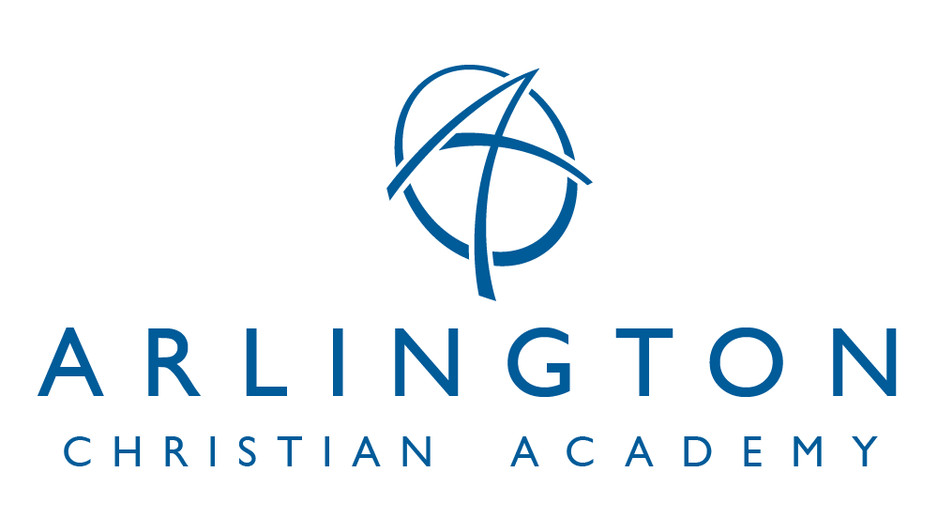
9801 Arlington Church Road * Mint Hill, NC 28227 * (704) 545-4589 * www.arlingtonacademy.org
FINANCIAL INFORMATION
2023-2024 SCHOOL YEAR
APPLICATION PROCESSING FEE: $250.00 per student for new students (non-refundable). This Application Processing Fee is required at the time of application to ACA. This fee covers the costs associated with the application process and any testing that is required.
CAPITAL IMPROVEMENT FEE: $75.00 per student (non-refundable). The Capital Improvement Fee covers the acquisition, upgrades, improvement and building program of our facilities. This fee helps cover expenses like classroom maintenance and repairs, restroom construction and maintenance, playground maintenance, parking lot construction, etc.
TUITION: $6,500.00 annually. This can be in full at the beginning of the school year, in monthly installments of $650.00 or quarterly.
ADVANTAGE: If full payment is made by September 30, 2023, a 2% discount will be applied to tuition.
DISCOUNTS: Please contact Arlington Christian Academy Administration at csustar@arlingtonacademy.org to determine what discounts your student is qualified to receive.
LATE FEES: There will be a $30.00 late fee accessed to all accounts that are 15 days delinquent. There will be a $30.00 fee accessed to all returned checks.
AFTERCARE: After School Care for Kindergarten through Second Grade students is available through Arlington Christian Academy. To secure a place for your child(ren) please contact Cindy Sustar at (704)-737-7426.

